WEB FRAMEWORKS

Create New Project:

Step 1:File->New->Spring Starter project

Step 2:Enter a name

Step 3:Select these item

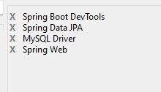

SAMPLE PROGRAM:

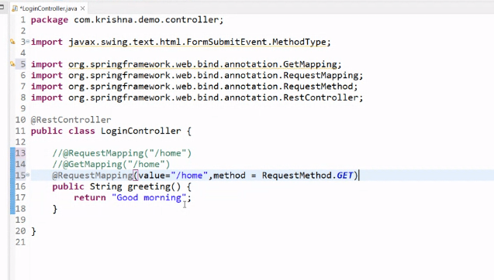

Project 1:

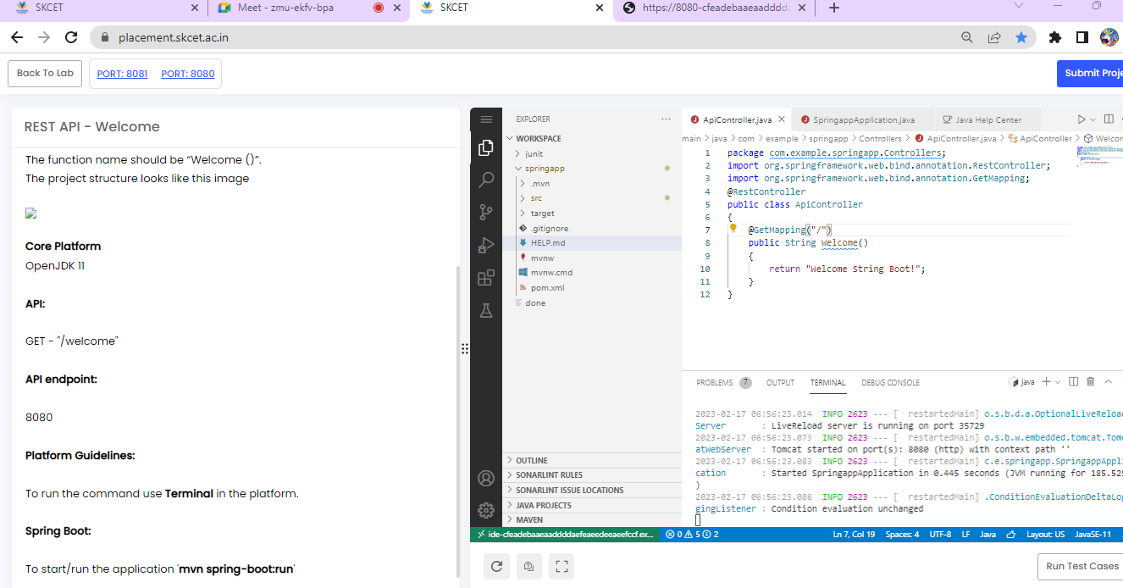

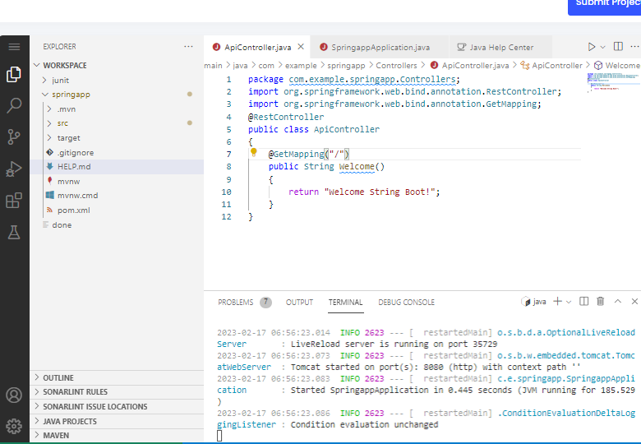

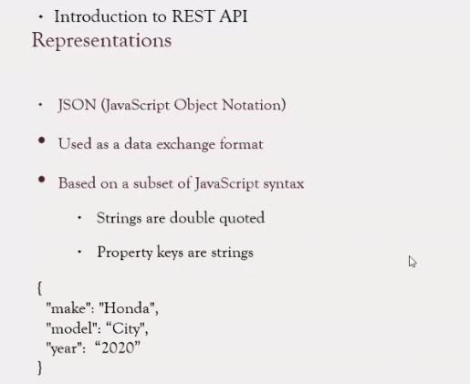

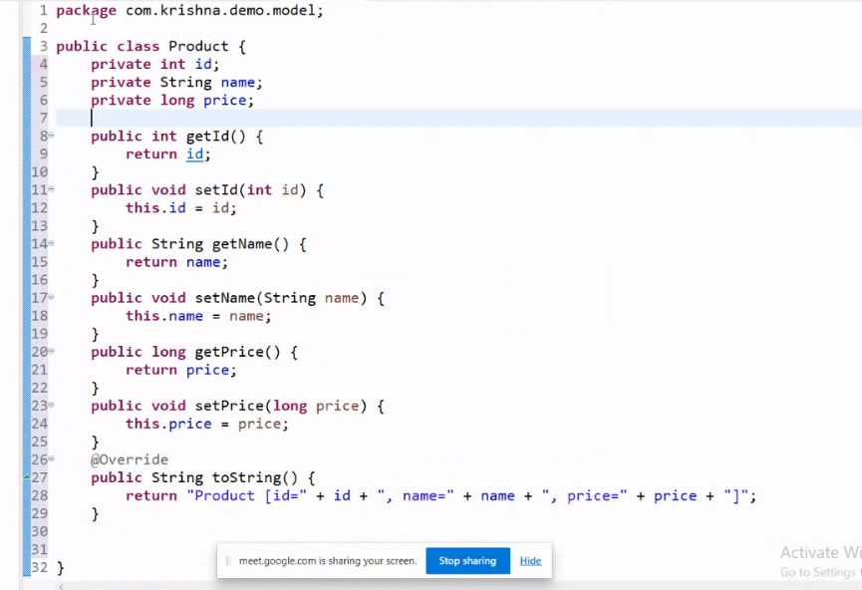

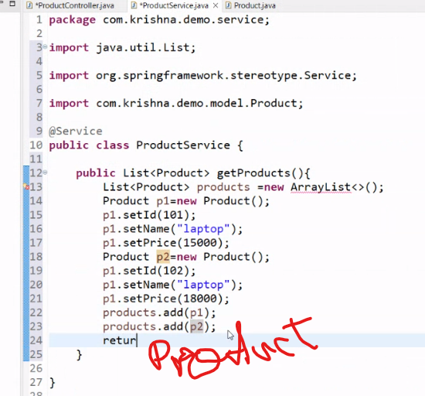

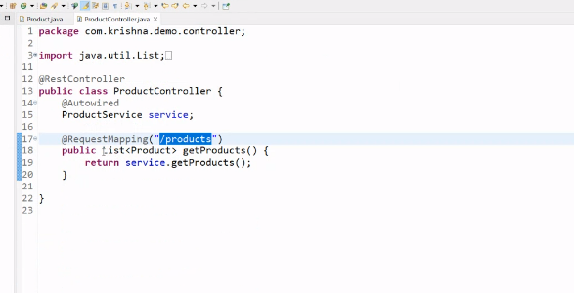

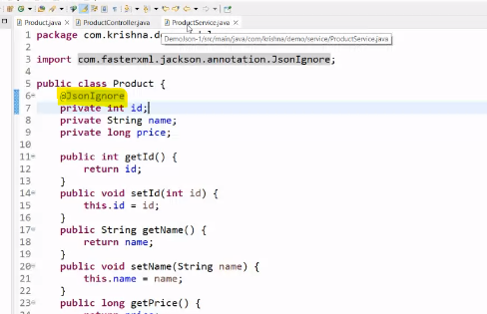

@JsonIgnore-if we ignore we can use it.In that id should be ignored.In output id not display….

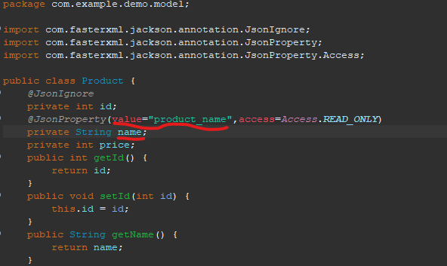

@JsonProperty-it should change the value of “name” as “product_name”

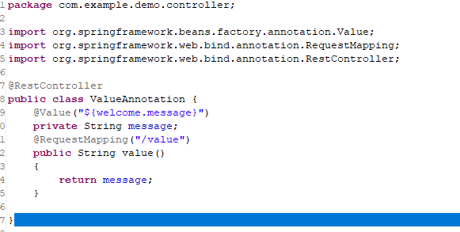

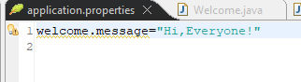

@Value- Should display the content in the application properties..

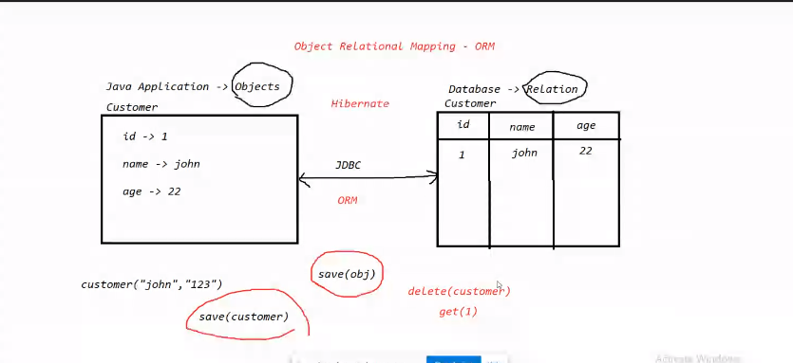

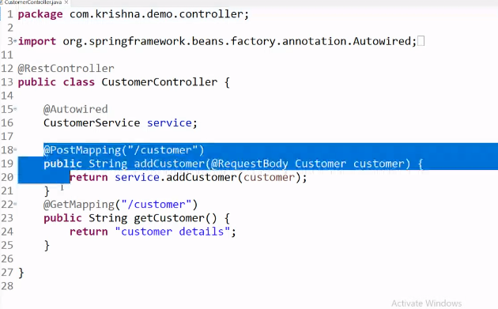

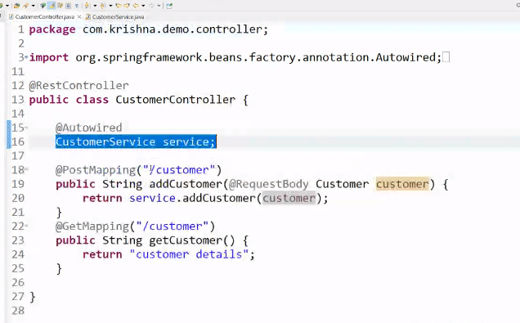

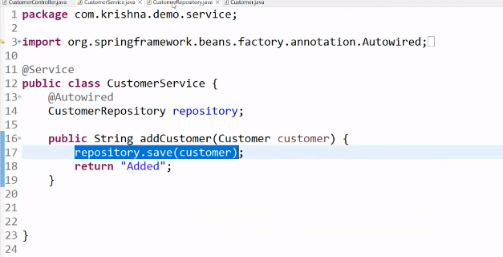

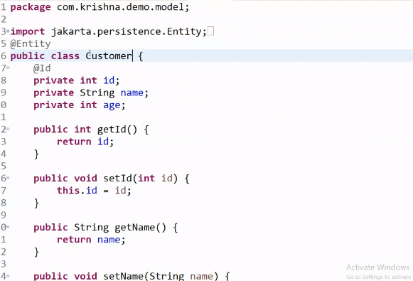

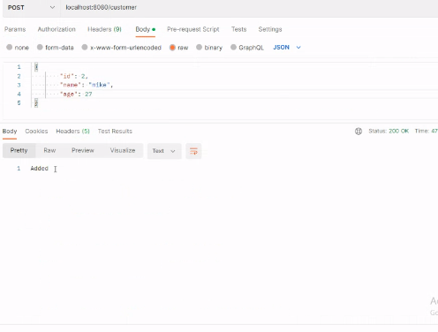

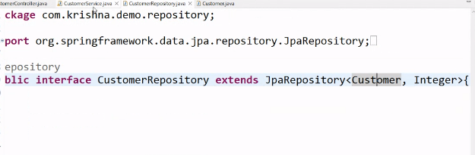

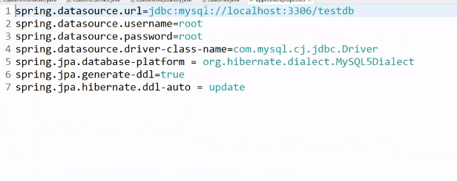

Database connection using JPA

The Java™ Persistence API (JPA) provides a mechanism for managing persistence and object-relational mapping and functions since the EJB 3.0 specifications.

Application properties

spring.datasource.url=jdbc:mysql://localhost:3306/testdb

spring.datasource.username=root

spring.datasource.password=root

spring.datasource.driver-class-name=com.mysql.cj.jdbc.Driver

spring.jpa.database-platform = org.hibernate.dialect.MySQL5Dialect

spring.jpa.generate-ddl=true

spring.jpa.hibernate.ddl-auto = update